PERSONAL INFORMATION | 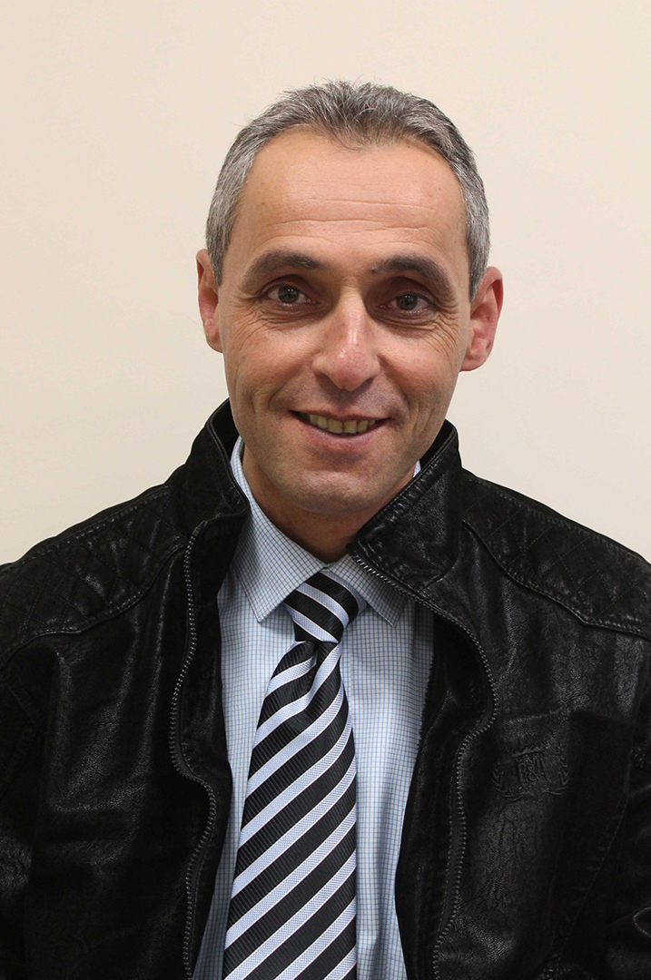  Muhammed Abed Alkader Amro

Arab American University-, Jenin, 240 , Palestine

+972-4-2510801 Ext. 211 +972-599-955255

mamro23@yahoo.com, mamro@aaup.edu
 | Sex Male | Date of birth 25.08.1973 | Nationality Palestinian
WORK EXPERIENCE

September 2016- 2019  Dean Assistan-2019- Till Present | Head of Physiotherapy Department
September 2016- 2019  Dean Assistan-2019- Till Present | Arab American University, Jenin, 240, Palestine, www.aauj.edu
  Arab American University, Jenin, 240, Palestine, www.aauj.edu
September 2016- 2019  Dean Assistan-2019- Till Present | - Strategic direction of the department  - Oversee and direct the planning, organizing, and implementation of physiotherapy education  - Academic leadership of the department which will include teaching, research and student support services  - Development and management of departmental staff  - Management and development of the department's finances and infrastructure
September 2016- 2019  Dean Assistan-2019- Till Present | Academic
September 2004- Till Present | Lecturer at Physiotherapy Department
September 2004- Till Present | Arab American University, Jenin, 240, Palestine, www.aaup.edu
September 2004- Till Present | - Developing and implementing new methods of teaching to reflect changes in research  - Designing, preparing and developing teaching materials  - Delivering lectures, seminars and tutorials  - Assessing students' coursework  - Setting and marking examinations  - Supporting students through a pastoral/advisory role  - Supervising students’ research activities
September 2004- Till Present | Academic

April 2011- March 2012  May 2001- June 2004 | Educational Consultant/Curriculum Development for Physiotherapy
April 2011- March 2012  May 2001- June 2004 | Ahliyya University, Bethlehem, Palestine
April 2011- March 2012  May 2001- June 2004 | - Provide guidance to committees of instructors responsible for revising and developing physiotherapy curriculum guidelines.  - Interpret provincial physiotherapy curriculum guidelines and assists physiotherapy school in the development of physiotherapy program to meet local needs.  - Provide leadership for the professional development of physiotherapy instructors  - Prepare physiotherapy curriculum guidelines and program materials  - Plan and make assessments of physiotherapy program effectiveness
April 2011- March 2012  May 2001- June 2004 | Academic  Physiotherapy specialist  Al-Meezan Specialist Hospital, Hebron, Palestine
  - Assist the clients’ served in achieving the individualized treatment plan goals
  - Implement community reintegration activities
  - Assist the clients’ served in understanding their needs and limitations
  - Participate in the team process and provide input as needed
  - Perform other duties as assigned in response to the clients’ serviced, office or program needs
  - Submit all required documentation in a timely manner
  Rehabilitation

EDUCATION AND TRAINING

1998-2001 | Ph.D Physical Rehabilitation
1998-2001 | National university of physical education and sports of Ukraine- Ukraine
1993-1997 | BSc Physical Therapy
1993-1997 | State university of physical education and sports- Ukraine

PERSONAL SKILLS

Mother tongue(s) | Arabic
Other language(s) | UNDERSTANDING |  | SPEAKING |  | WRITING
Other language(s) | Listening | Reading | Spoken interaction | Spoken production
English | C1 | C1 | C1 | C1 | C1
Russian | C2 | C2 | C2 | C2 | C2
Levels: A1/2: Basic user - B1/2: Independent user - C1/2 Proficient user
Common European Framework of Reference for Languages

Communication skills | - Ability to work individually and as a team member, good communication skills with client’s good ability to adapt to multicultural environments open minded, ability to look for creative solutions

Organisational / managerial skills | - Good experience in project and team management, leading workgroups and facilitation of team members

Computer skills | - Excellent command of Microsoft Office™ tools

Driving licence | - B

ADDITIONAL INFORMATION

Publications  Research Interest  Memberships  - Ghassan Abu-hijleh M.B.B.Ch.,D.F.M.,Ph.D  Professor of Anatomy  Faculty of Medicine  An-Najah University  Palestine  Email: Abuhijleh2001@hotmail.com  Tel: office: 092341003, Ext: 2148  - Mohammad Asia, BSc, MSc, Ph.D  Professor in Nursing  Dean, Faculty of the Allied Medical Sciences and faculty of Nursing  Arab American University  Palestine  Email: Mohammad.asia@aauj.edu  Tel: office: +972-4-2510801, Ext: 1234  References | - Amro m. & Alawna m (2018) Phone application for range of motion. International Journal of Development Research. 8(3)19-28  - Amro M (2020) Players and Coaches Awareness of Anterior Cruciate Ligament Injury  - Amro M and Ayman Aerobic Exercise Recommendation and Specification with COVID19  - Human Movement, Neurological rehabilitation, Outcome measures in rehabilitation and psychosocial aspect of disability  - Palestinian physiotherapy association

