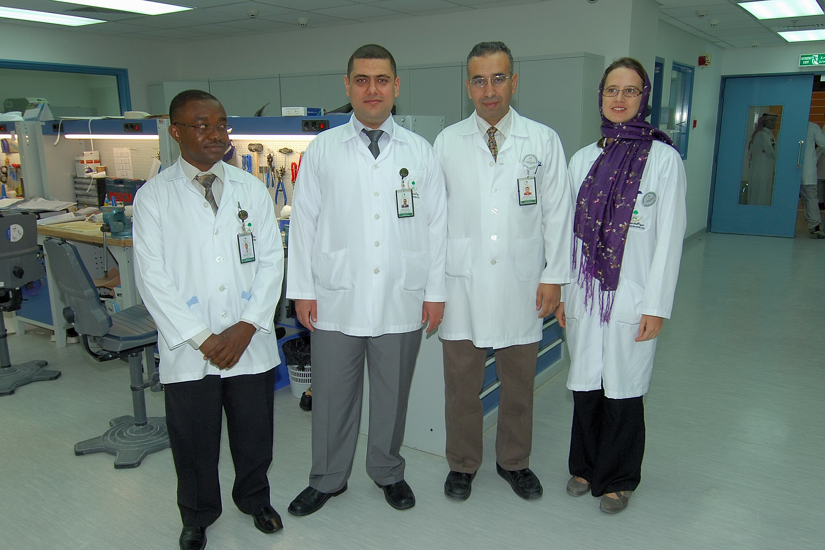

Haram Alrama, Hebron
Mobile Number: 00970597048418
E-mail Add: orthostone@yahoo.com
orthostone3@gmail.com

PERSONAL DATA

AGE: 50
DATE OF BIRTH: March 07, 1970
SEX: Male
CIVIL STATUS: Married
Children Three children
Nationality: Palestinian

EDUCATIONAL ATTAINMENT

2013 University of Strathclyde, Glasgow-Scotland, United Kingdom
MSc in Rehabilitation Studies.
1992-1996 University of Strathclyde, Glasgow-Scotland, United Kingdom.
“BSc. Honour Degree in Prosthetics and Orthotics”.
1991-1992, Clyde Bank Collage, Glasgow- Scotland, United Kingdom.
“Scottish Higher Degree”.
1985-1988 Arab Jordanian Institute Secondary School, Abu Dees-Jerusalem
“General Certificate of Education”.

HANDS ON COURSES

1999, Al-Quds Open University, Ramallah,
“60 hours course in Administration Skills”.
1999, United Kingdom, attended three weeks course in Appropriate Paper Based Technology (APT).
2001, Princess Basma Centre for Disabled Children,
“40 hours course in Total Quality Management”.
2004, Saint Joseph Hospital, Participating in one day workshop in Scars prevention and burns treatment by garment.
2004, Princess Basma Centre, Jerusalem,
“20 academic hours, use of GMFCS, GMFM 88&66 Tests for assessing the motor function of children with Cerebral palsy”.
2005, ID Management Consultants, Jerusalem, Participated in Application of Quality Management Tools in Hospitals (ISO 9000/IWA1).
2008, KFMC, Basic Infection control course I,
2008, 2ND Annual workshop on research Methodology. 12CME
Patient Affairs: Mutual Trust& Genuine Care International Forum. 7CME
2008 BLS Provider course and Certificate 4CME
2009 Review of Stance Control Technology Course, October 21st, KFMC, Riyadh. 7CME
2009 Clinical Research training Course for health care providers, December 13 and 14, KFMC, Riyadh. 6CME
2010 BLS Provider course and certificate 4 CME
2010 Training course in Manufacturing trans tibial (ICE CAST) and trans femoral (Ischial containment socket ) by OSSUR ,12-16 at KFMC.
2010 Attending three days workshop for amputation clinical Consideration. At King Fahad Medical City, 19 CME
2011Training of E-MAG ACTIVE, trip to Duderstadt, Otto Bock Germany
2011 Training workshop, Carbon Fiber Knee Ankle Foot Orthoses by Otto Bock, Riyadh
2011 Training on Writing A Research Proposal Course for Health Care Providers. KFMC, Riyadh.
2011 Work shop in CAD CAM designing of prosthetics an Orthotics moulds, by Vorum Company, KFMC, Riyadh.
2012 BLS Provider course and certificate 4 CME
2013 C-leg and Ischial containment socket workshop for two weeks by Otto Bock company, Germany at RTD, Rehabilitation hospital, KFMC, Riyadh.
2014 Essential leadership skills for three days, courtyard hotel, Riyadh, KSA
2014 BLS Provider course and certificate 4 CME
2015 Basic Tools of Quality, Riyadh, KSA, 8 CME
2015 Genium and C-leg microprocessor joints assembly and program training for 4 days , Otto bock , KFMC, Riyadh.
2016 C-Brace training and check brace fitting, five days, Riyadh, KSA by Otto Bock.
2017 Instructor methodology (Faculty Development Program for Clinical Educators. Educational Affairs. KFMC
2017 Spectra Level I training, Vorum Academy. KFMC
2018 Rivofit lower limbs, Otto Bock, KFMC.
2018 New Material Techniques, Alard,USA
2018 splinting materials of lower temperature, Orfit. KFMC.
2018 Sampling Techniques and Sample Size Determination for Quantitative Research, KFMC.
2019 Project management Professional, KFMC.
2019 Kenevo Expert ( microprocessor knee leg). Otto Bock, KFMC.

Conferences, Exhibition, Seminars and courses

- 1993,1994, 1995, 1996, 1998, attended British Association of Prosthetist and Orthotist annual conference, UK.
- 1996, attended the fifth annual meeting of European Society for Movement Analysis in C.P. children, UK.
- 1997 attended the international Society for Cerebral Palsy Workshop, Gaza.
- 1998, Bethlehem University, Bethlehem, attended five days course on Health Management for Rehabilitation personnel.
- 2008, Basic Infection control course I, KFMC
- 2008, 2ND Annual workshop on research Methodology
- Patient Affairs: Mutual Trust& Genuine Care International Forum
- 2008 BLS Provider course and Certificate
- 2009 Review of Stance Control Technology Course, October 21st, KFMC, Riyadh. 7CME
- 2009 Clinical Research training Course for health care providers, December 13 and 14, KFMC, Riyadh. 6CME
- 2010 Attending the ISPO- the 13 world congress in Prosthetics and Orthotics and the trade fair in Germany.
- 2010 Attending activity Towards E-HIM: Current Situation and Future Direction Symposium at King Fahad Medical City,14 CME
- 2010 Attending activity of Rehabilitation Technology: Trends and Challenges Conference at King Fahad Medical City,21 CME.
- 2011 Rehabilitation conference, 12CME.
- 2012 Cerebral Palsy update and Advances, 19CME.
- 2012 KFMC Innovation Fair, 14 CME.
- 2013 Orthotics and Prosthetics World Congress in Orlando from 18-22 of September, including orthotics and CAD CAM workshops.
- 2015 ISPO 15TH WORLD CONGRESS, LYON, FRANCE (SPEAKER), 22-26 of JUNE.
- 2016 The third Saudi International Exhibition for people with special Re
Quirments, 5-7 April.
- 2017 Updates on Research Projects in Rehabilitation Hospital. KFMC.
- 2018 Rehacare & Orthopedic Exhibition. China (Guangzhou).
- 2019 The first Jordanian International Congress for Prosthetics and Orthotics. Jordan University, Jordan.

WORKING EXPERIENCES

- 2008-2020 King Fahad Medical City Head of Orthotic and Assistive Technology Units and last 2 years Rehabilitation Technology Department chairman.
- 1996-2007 , PRINCESS BASMA CENTRE FOR THE DISABLED CHILDREN, JERUSALEM.
Head of Orthopaedic Workshop Department, Prosthetist /
Orthotist.
- 1998-2000, UNRWA and RED CRESCENT, NABLUS. One day a week in outreach clinic for Prostheses and Orthoses.

- 2000-2004, Bethlehem University, Bethlehem. Instructor,conducted a course Appropriate Paper Based Technology (APT) for physiotherapy students and occupational therapy students.

- 2006-2007 Researcher at MERQ which conducted a research on Cerebral palsy children.

- 2008-2010, King Fahad Medical City, Inpatients in charge for assessing and delivering service of Prosthetics and Orthotics.

- 2010- 2018 King Fahad Medical City, Instructor of updating nursing knowledge in Prosthetics and Orthotics rehabilitation.

- 2012, King Fahad Medical City Instructor of updating nursing knowledge in Prosthetics and Orthotics rehabilitation; Moving forward from good to great nursing Practice.

Present Position

Prosthetics and Orthotics department academic leader at Faculty of Allied health sciences. Arab American University

Main Duties through years
Responsible for the management of prosthetics and orthotics clinincs and the workshop technical jobs.
Prosthetist and Orthotist, working with physically disabled patients within the rehabilitation team ; assessing patients,planning the orthotic/prosthetic management, taking measurements, rectifying, manufacturing, fitting and delivering the devices.
Instructing and lecturing on Community Based Rehabilitation and Nursing.
Part time instructor at Bethlehem university of PT and OT students.
Full time faculty member at AAUP .
Participated in a research :Comparison of the Efficacy of Functional Motor Learning and Neuro – Developmental treatments of Children with Cerebral Palsy in Natural Environment by Means of Development of Low Cost assessment Methods.

Master research in gait of cerebral palsy children using tuned Ankle foot Orthosis, in clinical environment and outside environment.

Internship

TRAININGS ATTENDED | Period | PLACE
Prosthetics 4th year placement | Six months, 1995 | Musgrave Park Hospital, Belfast -North Ireland.
Orthotics 4th year placement | Six months, 1996 | Cappagh Orthopaedic Hospital, Dublin- Rep. of Ireland.

Educational Related Activities

1995, Three weeks educational Field Trip, Boston- Chicago.
1996, Two weeks educational Field Trip, Greece.

Membership

1993-1998 Was a member at British Association of Prosthetist and Orthotist from, UK.
2013-2018 Member of Health Care Professional Council, UK(PO 00732).
2010-2016 Member of Rehabilitation Hospital Documentation Team.
2013-2014 Member of Rehabilitation Hospital Performance Improvement Team.
2020 Member of International Society of Prosthetics and Orthotics (ISPO 03865). KSA ISPO Secretary and vice president.
2013-2020 Member of American Academy of Orthotics & Prosthetics (14406).
2014- 2020 Registered at Saudi Commission for health Specialties (08-R-A-0236421).
2021 Member of International Society of Prosthetics and Orthotics (ISPO 03865).Palestine

Languages
Arabic = speaks and writes fluent
English= speaks and writes excellent.

CHARACTER REFERENCES

With the permission as a regard to my character and integrity, I have the honor to refer you the following person;

- Dr. Laith Al-Falahi
Consultant and Chairman of
Rehabilitation Technology Department
at Rehabilitation Hospital
King Fahad Medical City
Kingdom of Saudi Arabia
Tel 011 288 9999 ext. 13383
Email: lalfalahi@kfmc.med.sa

2. Dr. Hassan Shakfa
Consultant physiatrist at rehabilitation hospital
Sports and traumatic medicine and pedologist
King Fahad Medical City
Kingdom of Saudi Arabia
Tel 011 288 9999 ext. 13330
Email: hshacfe@kfmc.med.sa

3. Mr. Haitham Ghazal
Senior Physiotherapist.
Supervisor of outpatients
King Fahad Medical City
Kingdom of Saudi Arabia
+ 966 11288 9999 ext: 13326
Email: hmghazal@kfmc.med.sa

4. Mr. Robert James Bowers
Supervisor and lecturer at
National Centre of Prosthetics and Orthotics,
University of Strathclyde
Telephone: +44 141 548 4699
Email: r.j.bowers@strath.ac.uk

5. Hypolit Benjamin Laurencin
Head of Prosthetic Unit
Rehabilitation Technology Department
King Fahad Medical City
TEL : 00966558193986
Email: hlaurencine@kfmc.med.sa

6. Sarah Day
Teaching Fellow
National Centre of Prosthetics and Orthotics,
University of Strathclyde
+44 (0)141 548 4034
sarah.day@strath.ac.uk

I hereby certify that the facts contained in this resume are true and completed

