C.V. 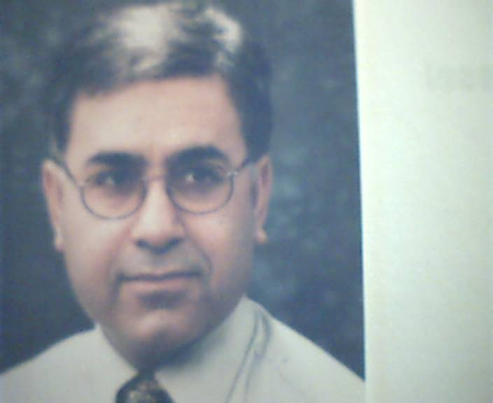

Person

Name Al-Hamdan

Vorname Yousif

Birthday 17.05.1960

Address Qabatia /Palestine

Telephone 0598809507

Nationality Palestinian and Swiss passport

Status married, 5 Children

Schools

1966 - 1976 Primary - Secondary school Qabatia, Palestine

1976 - 1979 High school, Jenin, Palestine

1980 - 1981 German Language, Mainz, Germany

Study

1981 - 1982 Studienkolleg, Aachen, Germany
(German high school diploma)

1982 - 1990 Medicine study, Kiel, Germany

1988 - 1992 Medical doctor, earning doctoral degree in internal medicine/ Clinical Pharmacology, Kiel, Germany

Works
1990 - 1992 A. I. P. ( Arzt im Praktikum)
Assistant physician, Internal medicine, University hospital Kiel, Germany

1992 - 1993 Work in the Clinical Pharmacology department University hospital Kiel, Germany

1993 - 2000 Assistant physician, Clinical Pharma Research, Birsfelden, Switzerland (CH)
Carried out various clinical studies in clinical pharmacology

05/00 - 05/01 Assistant physician, Solothurn
Höhenklinik hospital (CH)
Rehabilitation in Internal medicine, Musculoskeletal & post traumatic diseases

05/01 -12/01 Assistant physician, Kneipp hof hospital, Dussnang, (CH)
Rehabilitation in orthopaedic & internal medicine

01/02 - 07/03 Assistant physician, Chrischona hospital, Bettingen, (CH)
Rehabilitation in musculoskeletal, post traumatic & internal diseases

08/03 - 12/04 Assistant physician, Bethesda hospital, Basel, (CH) Rehabilitation in musculoskeletal diseases, internal disease/ Rheumatology

01/05 - 06/06 Assistant physician, Zurzach hospital, (CH)
Rehabilitation in musculoskeletal, post traumatic, internal disease/ Rheumatology, & Neurological disease

07/06 – 04/07 Assistant physician, Kantonspital hospital, Bruderholz, (CH)
Rehabilitation in Geriatric, musculoskeletal, post traumatic, internal disease/ Rheumatology, & Neurological disease

05/07 - 04/08 Senior physician, Solothurn hospital, (CH)
Rehabilitation in musculoskeletal, internal medicine /Rheumatology, & Neurological diseases

05/08 -12/10 Senior physician, Kantonspital hospital, Bruderholz, (CH)
Rehabilitation in Geriatric, Musculoskeletal and posttraumatic diseases, Internal medicine/Rheumatology and & Neurological diseases

1/11 – 04/15 Senior physician, Medical director, Kneipp hof hospital, Dussnang, (CH)
Rehabilitation in orthopaedic, Geriatric and internal medicine

Since 1.4.2015 Work at the AAUP - University (Assistant Professor, allied medical science)

Specialisation
- 2006: European board for Physical and Rehabilitation medicine

- 2007-2008: Certificate of competence in manual medicine SAMM (Swiss Medical Association for Manual Medicine)

-2009: Certificate of competence in Image Guided Spine and Joints Interventions

Languages

German Excellent
English Excellent
Arabic Excellent

