Dalal S. Iriqat Ph.D

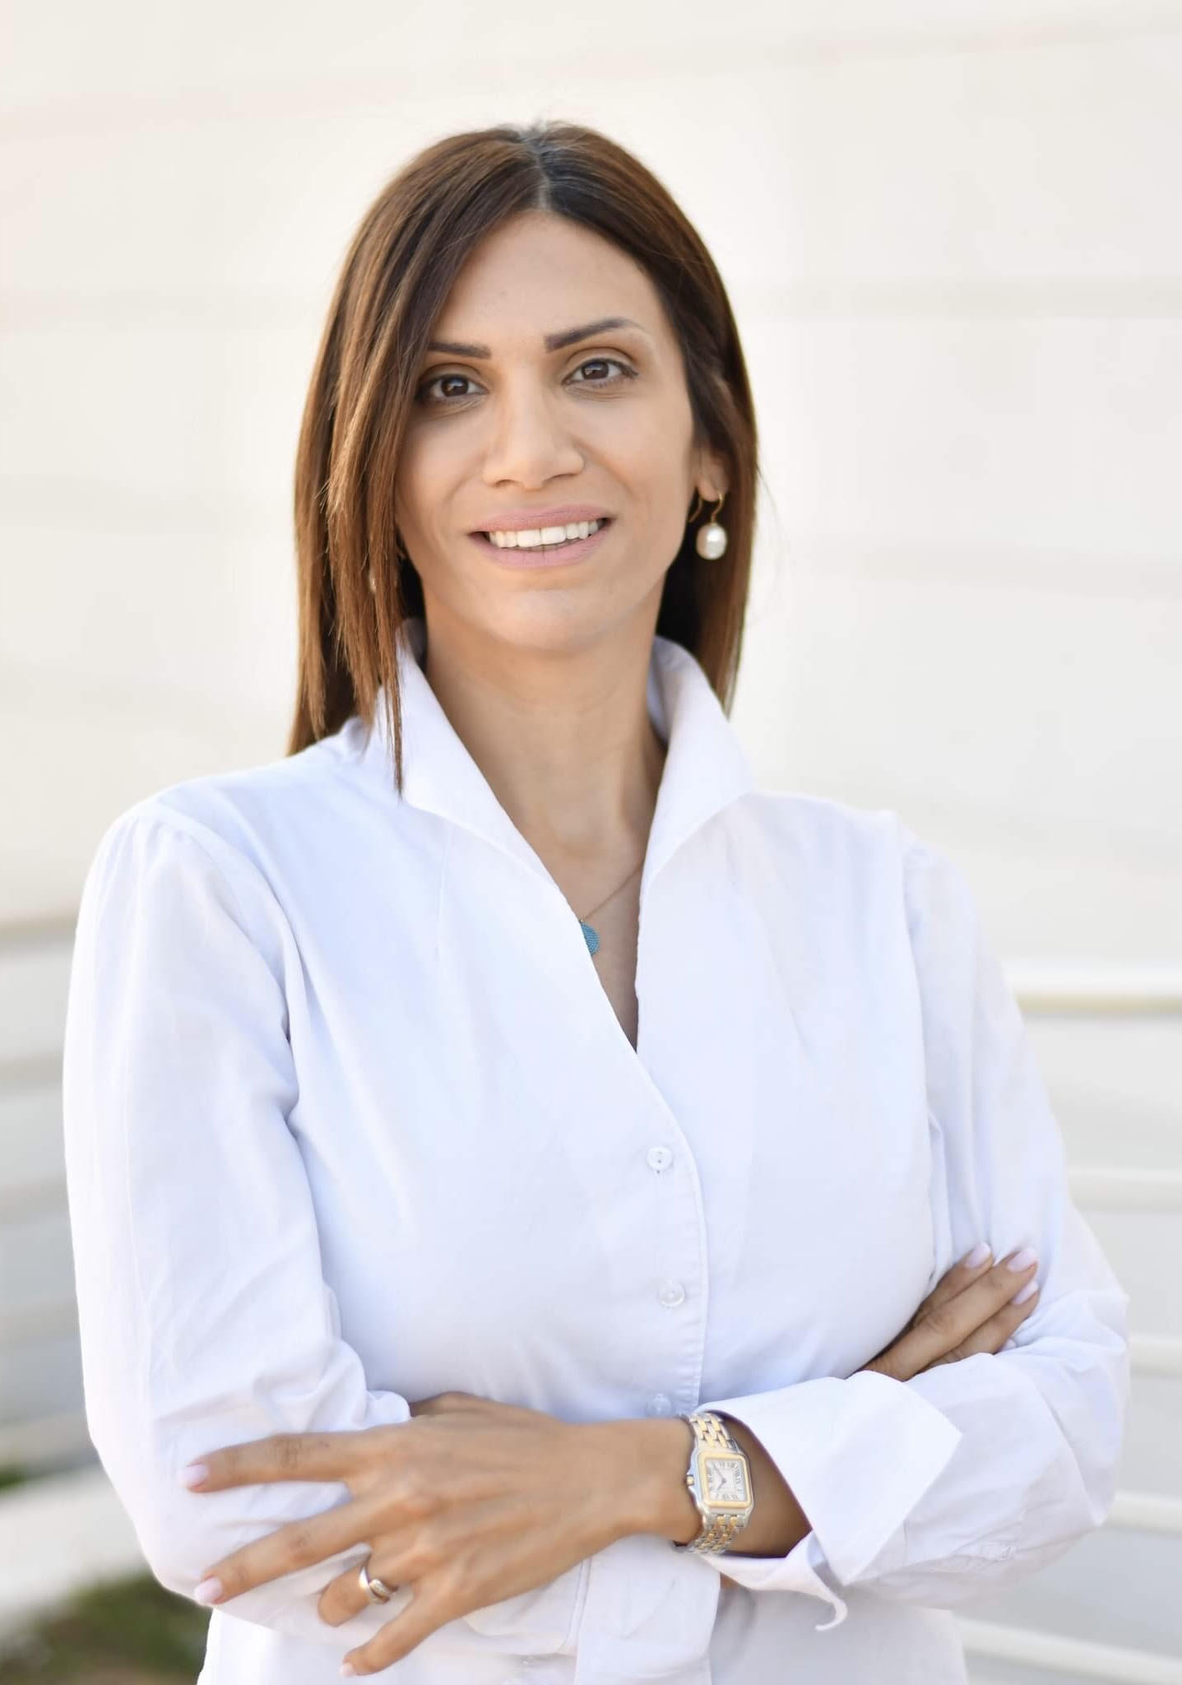

Associate Prof. @Arab American University 2015, Columnist @AlQuds Newspaper 2016, Founding member @MWMN 2017, Young Global Leader @WEF 2021, Founding President @BPW Palestine
Born in Jerusalem on May 17, 1982
Objective : To bring change into Palestinian society through Education, Strategizing & Diplomacy

Education

2024 -Harvard Kennedy School Executive Education, Global Leadership and Public Policy for 21st Century
2023 - University of Mohammed VI UM6P Executive Certificate, Investments & Sustainability/Africa
2021 - Stanford University Professional Certificate in Sustainability, Leadership and Business Strategizing
2017 - Harvard Executive Diploma in Leadership & Negotiations via Institute for Strategic Negotiations
2011 - PhD - Université Paris I, Sorbonne, France, Political Science / Public Administration, High Honors
2004 - MA - Westminster University, London, UK, Diplomatic Studies, Distinction
2003 - BA – University of Jordan, Amman, Jordan, Political Science GPA: 3.8/4.0 (95%)
2006 - Diploma - Université Paris 4, Sorbonne, Paris, France, French Language
2000 - Tawjihi- Jericho Secondary School, Jericho, Palestine, Diploma high school - GPA: 96.3%

Additional Training/ Courses

2024, Harvard Kennedy School Executive Diploma in Global Leadership
2023, UM6P, WEF, Morocco Executive Diploma in Investments & Sustainability in Africa
2021, Stanford University Sustainability, Leadership and Business Strategizing, USA
2020, Durham University Leadership in Mediation, MWMN, Italy MOFA
2020, MWMN, Online Leadership Master Class, Mediterranean Women Mediators
2018, Brussels, Belgium Egmont Institute for International Relations

2016, Genève, Switzerland Geneva Center for Security Policy on Leadership
2006-2007, London, UK Mediation, Facilitation in Conflict Resolution
2004, Pecdar, Palestine Negotiation Skills
2004, PASSIA, Palestine Ireland & Palestine seminar
2004, Jericho, Palestine Gender and Women Rights
2004, Ramallah, Palestine Civil Leadership Skills
2002, Amman, Jordan University of Jordan/ Diplomacy & Protocol

Professional/Work Experience

2024- Present AAUP- Arab American University - Associate Professor of Diplomacy & CR

2022-Present BPW- International Federation of Business and Professional Women- Founder & President

2021-Present WEF- World Economic Forum / Young Global Leader YGL

2018-2022 AAUP- Arab American University, Palestine – Vice President of International Relations
2016-2018 PMO- Prime Minister Office, PMO, Palestine Senior Advisor on Media & Strat. Comm.
2016-Present AlQuds newspaper, Palestine - Weekly columnist
2015-Present AAUP- Arab American University - Assistant Prof., Diplomacy & Strategic Planning
2015-2016 BZU- Institute of International Studies IALIIS Consultant/Assistant Prof. Diplomacy
2014-2015 UNDP - Future Palestine Consultant for Human Development Report
2011-2012 BZU- Birzeit University, Palestine Assistant Prof. Public Administration Department
2005 Peace Camp Canada, Ottawa, Canada - Co-director
2004-2005 BZU- Birzeit University (IALIIS) - Coordinator of International Relations

Leadership & Volunteerism

2022 BPW, Business and Professional Women Foundation – Founding President
2021 World Economic Forum Young Global Leader YGL/ WEF
2020 3al-Ard Initiative against Israeli settlements – Judge
2019-2022 Eco Peace Palestine – Board Member
2018-2022 Lycée Français International de Ramallah - Board Member
2018-2022 Policy & Conflict Resolution Studies Center, PCRSC – Founding Board Member
2017 Mediterranean Women Mediators Network – Founding Member
2017 AlRafic French universities Alumni Network – Member
2016 Palestine Model United Nations-University-Level - Advisor
2016 US Consulate Alumni board on Education - Advisor
2015 Global Voice for Autism - Advisor
2003-2004 Westminster University, London, UK President of Students’ Association, DALSA
2002-2003 University of Jordan, Amman, Representative Students’ Union, Faculty of Social Sciences

Qualifications & Skills

- Motivational Writer and Speaker
- 20+ years of professional experience in teaching and academia
- Creative with the ability to improve & learn.
- Team Leader
- Strategic Empathy & Communication skills
- Strategic Thinking/Planning, Negotiations and Diplomacy
- Arabic, English & French skills

Published Works/ Articles

^{May 2024} | Dalal Iriqat, 2024, Palestine: Anatomy of a Genocide, LOM Ediciones, Chile ISBN 978956001820. Editors: Farida Zeran: Rodrigo Karmy : Paulo Slachevsky
^{May 2024} | Dalal Iriqat. (2024). Paradiplomacy for Non-recognized States: Case of Palestine. International Relations and Diplomacy, Jan.-Feb. 2024, Vol. 12, No. 1, 34-39.  (ISSN 2328-2134) (doi: 10.17265/2328-2134/2024.01.004)  https://www.davidpublisher.com/index.php/Home/Article/index?id=50663.html
^{Jan 2024} | Una McGahern, Dalal Iriqat, Amin Al-Haj, Building a border-city university in occupied Palestine: Developing a cross-border “resistance economy” in practice, Political Geography, Volume 108, 2024, 103030, ISSN 0962-6298 https://doi.org/10.1016/j.polgeo.2023.103030  https://www.sciencedirect.com/science/article/pii/S0962629823002081
^{Jan 2024} | Iriqat, Dalal, Gaza Forward (Hamas at the Table), January 2024, The Day After: A New Political Paradigm, This Week in Palestine at:  https://thisweekinpalestine.com/gaza-forward-hamas-at-the-table/
^{Nov 2023} | Nakba Continued: War Magazine, Issue 36, 1st November 2023 https://shuddhashar.com/nakba-continued/
^{Oct 2023} | Gaza: The Caged Context, Institute for Palestine Studies IPS, 13th October 2023. https://www.palestine-studies.org/en/node/1654395
^{June 2023} | 3 Years Since The Brutal Murder of Ahmad Erekat, June 23rd 2023 https://palestineobserver.org/2023/06/23/3-years-since-the-brutal-murder-of-ahmad-erekat/?fbclid=IwAR0JQzO2BTuK8MURG57c88V8rxILjX1qXu4-5owWqt9jdK-pOt0G9yrnn4U
^{May 2023} | 75 Years of Ongoing Nakba: 75 Years of Israeli Occupation, May 2023, Palestine Israel Journal PIJ, focused on 75 years Palestine Nakba/ Israel Independence. Vol 28, No. 1 & 2, 2023, Pp. 6-15.
^{April 2023} | Iriqat, D.S.M. (2023). Legal Framework, Institutionalization, Tools, and Motives of Palestine’s Paradiplomacy. In: Gürbey, G., Hofmann, S., Ibrahim Seyder, F. (eds) Between Diplomacy and Non-Diplomacy. Palgrave Macmillan, Cham.  https://doi.org/10.1007/978-3-031-09756-0_5 Springer International Publishing. P 93-110  ISBN 978-3-031-09755-3 ISBN 978-3-031-09756-0 (eBook)
^{April 2023} | TWiP, A National Brand and Soft-Power Instrument for Palestine. Dalal Iriqat  This Week in Palestine Full article: https://thisweekinpalestine.com/wp-content/uploads/2023/04/300-002.pdf?mibextid=unz460&fbclid=IwAR3P1XdArgxLHGZztxh6jhaE1vi5g6llxBhz9I-RGO9wYXDN_qxrse2zydk&mibextid=unz460
^{March2023} | The Empowered Women of Palestine:  Closing the Gender Divide via Representation and Inclusion, Dalal Iriqat.  This Week in Palestine Full article  https://thisweekinpalestine.com/the-empowered-women-of-palestine/?mibextid=unz460&fbclid=IwAR0x2bW0leVTgvGoRQYMYVi3O3QY4WKgMfW0_pIZ70MJSj3DMmfda0XnPSs
^{Dec 2022} | Saudi Arabia and Israel Can't Be Partners Without the Palestinians, Iriqat Dalal, 22 Dec 2022, Haaretz  https://www.haaretz.com/middle-east-news/2022-12-21/ty-article-opinion/.premium/saudi-arabia-and-israel-cant-be-partners-without-the-palestinians/00000185-34b0-d5e0-ab8f-7cf79c690000?fbclid=IwAR02UdGhU4annK_Fw7Txw-jYxXXvIytcqDD5g9Ded2mfiPXRIB6N4de9dSM
^{Nov. 2022} | Diplomacy for Democracy in Palestine Post-Oslo: Success or Failure? Pp.149-160. Islam & Democracy, Reconciliation and Conflict Resolution Volume II, 2022 by wbg (Wissenschaftliche Buchgesellschaft), Darmstadt, ISBN 978-3-534-40651-7 Elektronisch ist folgende Ausgabe erhältlich: eBook (PDF): 978-3-534-40652-4  file:///Users/mac/Desktop/Publications%20&%20Conferences%20%20/Flensburg%20summer%20/Islam%20and%20Democracy%20pdf.pdf
^{July 2022} | The One Thing Biden Needs to Know About the Palestinians, Iriqat Dalal, 11 July 2022, Haaretz  https://www.haaretz.com/opinion/2022-07-10/ty-article-opinion/.premium/the-one-thing-biden-needs-to-know-about-the-palestinians/00000181-e824-d9a3-a3e1-edbe4cd70000?fbclid=IwAR0lWXlw30Pk1OgDpWQDe64QR2A1Kpp0lFdakFBkJHUeXvK7NKfcEdW5jic
²⁰²² | Three Decades of a process Without Peace: How to Break the Impasse ? Palestine-Israel journal , Vol 27 No. 3& 4, 2022 Pp. 86-94 https://pij.org/articles/2210/three-decades-of-a-process-without-peace-how-to-break-the-impasse
^{Jan 2022} | Coercive Diplomacy: Camp David 2000, From Clinton to Trump, January 2022, Dirasat, Human and Social Sciences, University of Jordan, Vol 49, Issue 1, Pp. 625-638, ISSN: 2663-6190  https://journals.ju.edu.jo/DirasatHum/article/viewFile/111101/12659?target=_blank
^{Oct 2021} | Why Is Israel Dictating America’s Mideast Policy? Iriqat, Dalal, Haaretz, 28/10/2021  https://www.haaretz.com/us-news/.premium-why-is-israel-dictating-america-s-mideast-policy-1.10332959
^{Oct 2021} | Rubber Bullet Eye Injury During Covid-19 Pandemic and The Situation in Palestine, Iriqat, Dalal, Iriqat, Salam, Gnoscience group, Vol 2, Issue 2, Pp.1-5, October 2021  https://gnoscience.com/uploads/journals/articles/266386108531.pdf
^{Oct 2021} | Diplomacy in the Perspective of Peace Building : From Coercion to Dictation (Israel & Palestine), Reconciliation and Refugees, Vandenhoeck & Ruprecht, Ch 8, Pp. 127-147, ISBN -10 : 3525568568. October 11, 2021  https://www.aaup.edu/sites/default/files/Publications/VRV_Tacchini.pdf
^{July 2021} | Women in Politics and Conflict Resolution at the Mediterranean Women Mediators Network July 2021 https://womenmediators.net/july-2021/
^{July 2021} | Not the Palestine I Imagined, Nor Was Promised, The Media Line, 4th July 2021  https://themedialine.org/news/opinion/opinion-not-the-palestine-i-imagined-nor-was-promised/
^{June 2021} | Arab Israeli Conflict, Is there a Possibility for a Two States Solution? Arab Thinking Forum, 9th June 2021 https://arabtf.uk/images/1626012352.pdf
^{June 2021} | America Is Offering Money But That Is Not Enough, The Media Line, 6/6/2021 https://themedialine.org/news/opinion/america-is-offering-money-but-that-is-not-enough/
^{May 2021} | Sheikh Jarrah: The Violation of International Law, Contextualizing Sheikh Jarrah. 21/5/2021 https://www.palestine-studies.org/en/node/1651316
^{Nov 2020} | Women Political Participation, We World Index, November 2020. Women and Children in Times of Covid-19. Available at: https://www.weworld.it/wp-content/uploads/2020/11/WeWorld-Index-en-2020.pdf
^{Oct 2020} | “Public Diplomacy in the 21st Century”, This Week In Palestine, October 2020 issue, themed “Palestine, A Donor Country?” available online at  http://www.thisweekinpalestine.com/public-diplomacy-in-the-twenty-first-century/
^{May 2020} | “Israeli Politics During COVID19 and The Impact on Palestine, Shedding on Annexation” Book published by Diyar.ps. May 2020 available online at  https://www.diyar.ps/the_double_lockdown.pdf
^{April 2020} | “The Deal of the Century”, April 2020. Paper published in a book with the Palestine Israel Journal PIJ, Book on the Deal of the Century April Issue 2020 available online at  https://www.pij.org/articles/2011/the-deal-of-the-century-from-a-palestinian-perspective
^{Mar 2020} | “Leadership and Planning in the Age of COVID-19”, March 2020.  https://www.thisweekinpalestine.com/wp-content/uploads/2020/03/005-1.pdf?fbclid=IwAR2BqtO4YwN5X3Crgt7YbLYkQBlyWH8v2h5B3UXgQg5V2m_62g434DXfmg8
^{Feb 2020} | “Peace to Prosperity: A Wake-Up Call for Palestinians and Beyond” February 2020.  https://themedialine.org/news/opinion/peace-to-prosperity-a-wake-up-call-for-palestinians-and-beyond/
^{Dec 2019} | “The 21st Century Mediator in the MEPP” Paper published in a book with the Palestine Israel Journal-Jerusalem PIJ, and Israel Palestine Thinking Together-Berlin. December issue. 2019. https://www.pij.org/articles/1972/mepp-mediation-in-the-21st-century
^{Nov 2019} | Mentors E-Book for Entrepreneurs, Ritaj in collaboration with 24 Authors. 4/11/2019. Pages 22-24  https://ritajms.com/wp-content/uploads/2
^{Aug 2019} | “Nation/City Branding” This Week in Palestine, August 2019 issue http://thisweekinpalestine.com/nationcity-branding-palestine/
^{May 2019} | “Palestinian Nation Branding via Public Diplomacy” International Relations and Diplomacy, May 2019, Vol. 7, No. 05, 202-216 doi: 10.17265/2328-2134/2019.05.002  http://www.davidpublisher.org/Public/uploads/Contribute/5d005eec16e36.pdf
 | “Construire un Etat Palestinien” by the National Center of Reproduction of PhD theses at the university of Lille 3, France. www.diffusiontheses.fr
^{December 2018} | Israeli army shatters the illusion of normalcy in Ramallah, 972 Magazine 16th Dec. 2018  https://www.972mag.com/israeli-army-shatters-illusion-normalcy-ramallah/
^{March 2018} | A Palestinian mother’s open letter to Melania and Ivanka Trump, 972 Magazine, 21st March 2018  https://www.972mag.com/a-palestinian-mothers-open-letter-to-melania-and-ivanka-trump/
^{April 2017} | Banksy’s new project tells the story of Palestine, 972 Magazine, 4thApril 2017  https://www.972mag.com/banksys-new-project-tells-the-story-of-palestine/
^{October 2016} | Palestinian Mothers Teach Life, Not Hate, 972 Magazine, 11th October 2016  https://www.972mag.com/palestinian-mothers-teach-life-not-hate/
²⁰¹⁴ | Palestine Human Development Report 2014 – UNDP  https://www.undp.org/content/dam/papp/docs/Publications/UNDP-papp-research-PHDR2015.pdf  http://www.ps.undp.org/content/papp/en/home/library/human_development/nhdr-2015.html

Conferences

2024 | 12-13th May Amman, Jordan  The University of Tokyo and University of Jordan, the Research Center for Advanced Science and Technology Open Laboratory for Emergence Strategies (ROLES) at the University of Tokyo and the Center for Strategic Studies at the University of Jordan. Paper entitled “Rebuilding Gaza and Envisioning the Solution of the Palestine Issue: Regional Cooperation and Japan’s Efforts”
2024 | 27-29th April Riyad, Saudi Arabia  World Economic Forum Special Meeting on Global Collaboration, Growth and Energy for Development
2024 | 3-5th Feb Rome, Italy  Rome Med Dialogues Extraordinary Expert Meeting to explore new and creative ways to help de-escalate tensions in the Middle East and reduce the suffering of people affected by the current turmoil.
2022 | 31Oct-2ndNov Ramallah, Palestine  IPS, Institute of Palestine Studies, Reassessing the British Mandate in Palestine: Colonialism & Settler Colonialism II, Paper entitled ”The Undermining of Local and National Governance at the End of the Mandate”
2022 | Dec 1-3 Rome, Italy  Rome 2022 MED Dialogues, Quest for Peace in the Middle East
2021 | August 21-8-2021 Ramallah, Palestine  Masarat 10th Conference: Palestine in a Changing Regional and International Environment, Speaker
2020 | February 28-29 2020 KualaLumpur, Malaysia  The United Nations International Conference for the Committee on the Inalienable Rights of the Palestinian People. Expert speaker via Videoconference on the question of Palestine post the ‘Deal of the Century’ https://www.un.org/press/en/2020/gapal1430.doc.htm, Speaker
2020 | February 19-21 2020 Istanbul, Turkey  The Eurasia Higher Education Summit. Speaker, Speech entitled “Adaptive Leadership in Higher Education”, Speaker
2019 | November 13th 2019 Ramallah, Palestine  Conference on Anti-Corruption in Palestine on 5 years of joining the UN treaty on anti-corruption by Human Rights and Democracy Center Shams and Friedrich Naumann Stiftung. Paper entitled: مدى التزام دولة فلسطين بمتطلبات اتفاقية الأمم المتحدة لمكافحة الفساد من خلال التدابير التشريعية والتنفيذية والقضائية, Speaker
2019 | November 6th 2019 Durham, UK  Workshop at the Institute of Advanced Study at Durham University, UK.  Ideational dimensions of Mediation in the 21st century, paper titled: Mediation for the 21st Century: Connecting the Local and the Global, Speaker
2019 | June 2019 Flensburg, Germany  Europa-Universitat Flensburg Summer School on Islam + Democracy, “Diplomacy to Democracy in Palestine: Success or Failure?”, Speaker, paper presenter “Diplomacy to Democracy in Palestine Post Oslo: Success or Failure?” Europe-Universitat Flensburg 11-14 June 2019 / Series “Reconciliation and Conflict Resolution” by the Wissenschaftliche Buchgesllschaft (WBG), Darmstdat Germany
2018 | Dec. 2018 Amsterdam, Netherlands  University of Amsterdam. Speaker on “25 years of the Oslo Accords”, Speaker
2018 | Aug. 2018 Jena, Germany  Friedrich Schiller University, Jena, Germany, “Reconciliation in the Middle East & North Africa: An Interdisciplinary Research”, Paper presenter / Speaker “Diplomacy in the Perspective of Peace Building: From Coercion to Dictation” Jena center for Reconciliation, Fredreich schiller University, Germany. August 2018. Diplomacy in the Perspective of Peace Building: From Coercion to Dictation
2018 | Mar. 2018 Dead Sea, Jordan  Swedish Institute Alexandria, “Palestine and Regional Geopolitical Development”, Speaker
2016 | Nov. 2016 Stockholm, Sweden  Folke Bernadotte Academy, “Role of Small States Mediators in Israel & Palestine”, Speaker
2001 | 2001 New York, USA  The International Peace conference, Speaker
1999 | 1999 The Hague, Netherlands  The Hague Appeal for Peace Conference, Speaker
1998 | 1998 Villars, Switzerland  The First Middle-East Youth Summit, Speaker

Awards

2021, International Young Global Leader- World Economic Forum WEF
2003-2004, London UK Westminster University Scholarship for Peace
2003, Amman, Jordan Nabil Barakat Award for Excellence/ University of Jordan
1998, Villars, Switzerland Novartis Corporation Award for Leadership

