Curriculum Vitae

Personal Informations
Name: Haytham Samih Nimir Issa

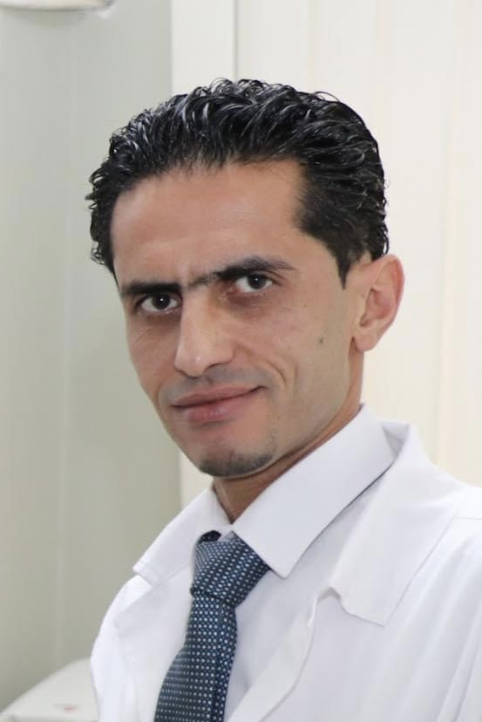

-Date of Birth: 2 -6-1979
- Place of Birth: Jerusalem
-Marital Status: Married.
-Address: Bethlehem, Palestine
-Email: haytham.issa@aaup.edu
-Telephone: +97 0595 565656

-Languages: Arabic, English.

- Member of the high scientific committee associated with the Palestinian medical council(2018-present)

- Assistant Professor of oral and maxillofacial surgery -Arab American University (2011-present )

- Consultant oral and maxillofacial surgeon at Almizan Hospital \ Istishari Arab Hospital \Bethlehem Arab Society for Rehabilitation(2011- present )

- Representative of the Palestinian universities
in the Scientific Committee of the Arab Medical council 2013-2017

- Head of department of oral and maxillofacial surgery ,Periodontology,Implantology and oral pathology (Arab - American University)2012-2016

- Head of the Scientific committee of the Palestinian Dental Association

- Chairman of the Palestinian Association of Oral And Maxillofacial Surgery

- Member of the Scientific Committee of the Palestinian Medical Council

- General secretary of the Palestinian Association of Dental Implantology ( PADI ) 2012

- Board member in the Palestinian Association of Dental Implantology 2011

-Education and Qualifications:

- The Arab Board in oral and maxillofacial surgery 2010

The Arab League
Council of Arab Health Ministers
The Arab Board of Health Specializations
General Secretariat, Damascus, Syria

- The Palestenian Board in oral and maxillofacial surgery 2010

- Higher Specialization in Oral & Maxillofacial Surgery 2010
Faculty of graduate Studies
University of Jordan
Amman – Jordan
General grade: very good
- Diploma of oral surgery, 2006
Faculty of Dentistry
Alexandria University

- B.D.S Degree in Dentistry, 2003
College of Dentistry
Baghdad University

- Certificate of general secondary education examination (High School)
Terra sancta High School – Bethlehem –Palestine (1997)

