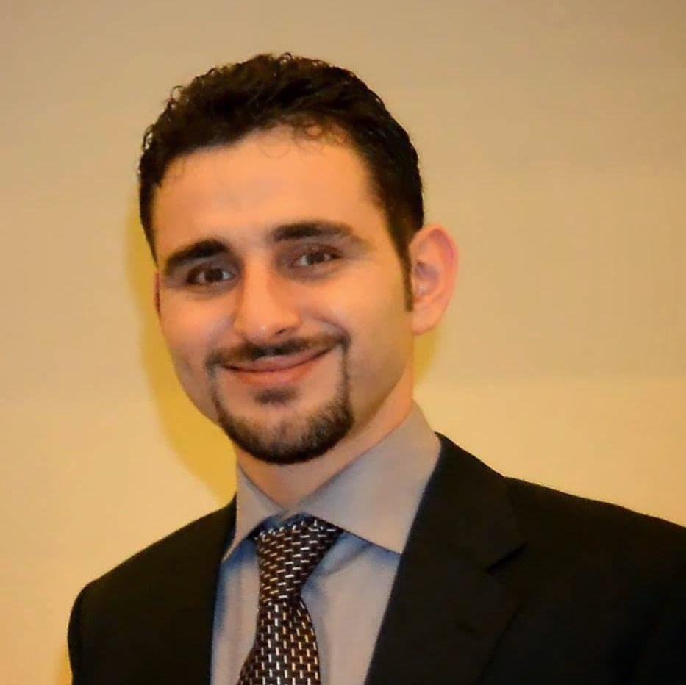
Dr. JAMIL A. J. OWDA

EMAIL: jamil.owda@aaup.edu
MOBILE # 00972 599 599 007

EDUCATION:

Secondary high school | 2002-2003 |  | ALFADELYIA HIGH SCHOOL- PALESTINE
BACHELOR OF DENTAL SURGERY (BDS) | 05/01/2004-  09/01/2009 | De’MONTMORENCY COLLEGE OF DENTISTRY LAHORE. | UNIVERSITY OF HEALTH SCIENCES, PAKISTAN.
HOUSE JOB | 01/03/2009-  15/08/2010 |  | PUNJAB DENTAL HOSPITAL, PAKISTAN.
ORAL& MAXILLOFACIAL SURGERY TRAINING /RESIDENCY (including rotations) | 27/08/2010-  10/11/2015  5 Years | DEPARTMENT OF ORAL& MAXILLOFACIAL SURGERY | MAYO HOSPITAL  LAHORE  PAKISTAN
BDS  Palestinian equivalence exam | MARCH / 2016 |  | PALESTINIAN MEDICAL & DENTAL COUNCIL
(ORAL& MAXILLOFACIAL SURGERY)  PALESTINIAN BOARD | MAY /2017 |  | PALESTINIAN MEDICAL & DENTAL COUNCIL

Certified Workshops attended

- Communication skills workshop “ WHO collaborating center for research & training in educational development of health personal”

- Research methodology , biostatistics & dissertation writing “ WHO collaborating center for research & training in educational development of health personal”

- Primary surgical skills workshop“ WHO collaborating center for research & training in educational development of health personal”

- Introduction to computer & internet workshop “ WHO collaborating center for research & training in educational development of health personal”

WORKING EXPERIENCE:

- 1.5 year house job experience at PUNJAB DENTAL HOSPITAL, Lahore, Pakistan. (1 year house job training at OMFS and 6 months at other different dentistry depts.) from 01/03/2009--- 15/08/2010.
- 5 years Residency at department of oral and Maxillofacial Surgery, Mayo hospital, Lahore.27/08/2010--- 26/08/2014.
- .Rotations as part of the residency program : 2 months at Plastic Surgery Dept , 2 months at Neurosurgery Dept. , 2 months at E.N.T. Dept. , 2 months at General surgery Dept. , 2 months at General Anesthesia Dept , 1 month at Orthodontics Dept. , 1 month at Prosthodontic Dept.
- Teaching and lecturing of BDS final year and 1st year students during the residency period , and giving lectures and hands on workshops at Palestinian dental council, Tulkarem branch.
- 3 years working experience/part time job as Oral surgeon at MIDCITY HOSPITAL, DR. EHSAN UL HAQ DENTAL, ORAL & MAXILLOFACIAL SURGERY CLINIC, Lahore, Pakistan. Since 01/09/ 2012--- 30/8/2015.
- Working as Oral & Maxillofacial Surgeon at AL-ZAKAT HOSPITAL , Tulkarm - Palestine. Since 1/7/2016 - till date .
- Assistant professor at ARAB AMERICAN UNIVERSITY, Palestine. since October 2018 - till date.

SKILLS:
- Patient communication and treatment planning.
- Excellent Skills at minor and major oral surgeries (impactions, cysts, alveoloplasty, implant, fracture management, etc.)
- Researches and article writing.
- Students teaching and communicating.

LANGUAGES
- Arabic
- English
- Urdu .

