Ireland-Palestine Scholarship Programme

Application Form

2020 Entry

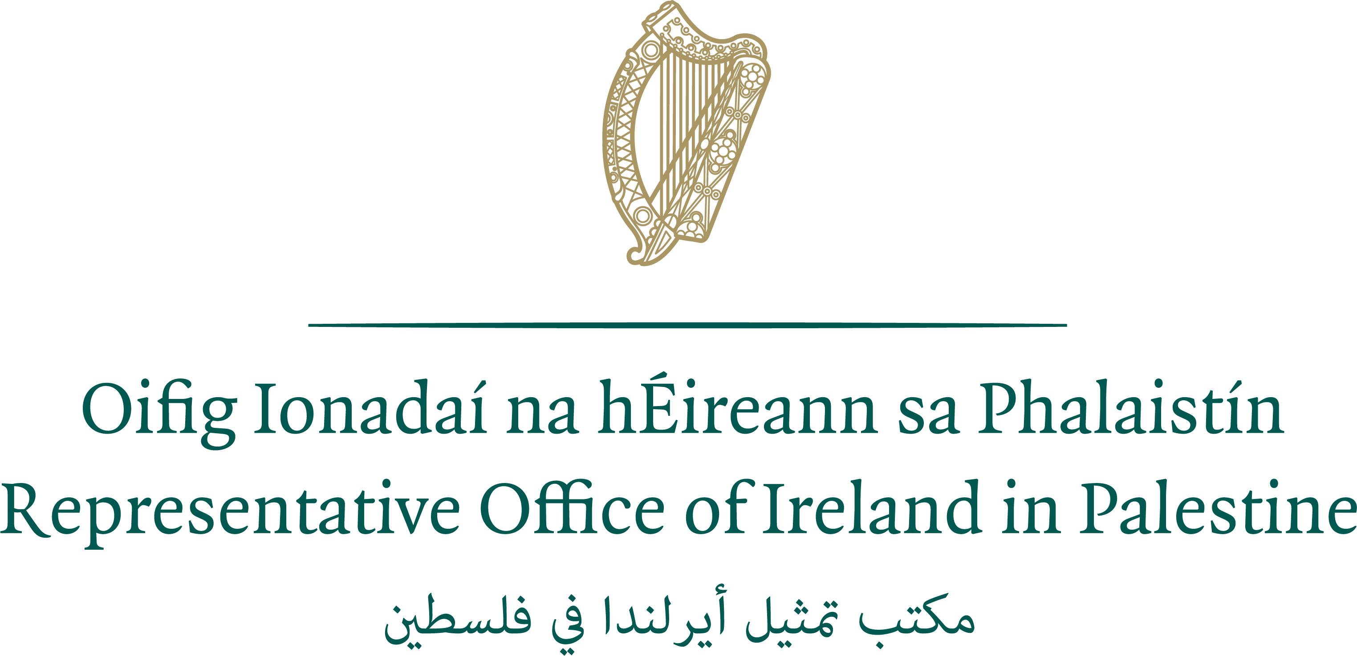

IRELAND-PALESTINE SCHOLARSHIP PROGRAMME (IPSP)

The Ireland-Palestine Scholarship Programme is part of Ireland’s programme of assistance for Palestine, which supports the search for a lasting and just political solution to the Israeli-Palestinian conflict. This programme reflects Ireland’s longstanding commitment to the development of a viable, sovereign Palestinian state, as part of a two-state solution to the Middle East conflict. Recognising that long-term, sustainable development in Palestine is closely linked to a successful outcome to the Middle East Peace Process, for over two decades, our programme has aimed to meet the needs of the most vulnerable Palestinian people, while supporting the Palestinian Authority to build the institutions of a Palestinian state.

Development of the education sector in Palestine has been a long-standing focus area for Ireland in Palestine. The Ireland-Palestine Scholarship Programme aims to further broaden Ireland’s support for educational opportunities available to Palestinians.

The Ireland-Palestine Scholarship Programme offers full scholarships to Palestinian students to study in higher education institutions in Ireland for one year at Master’s Level, including tuition fees, flights, accommodation and living expenses. The Programme provides opportunities for candidates to study in a wide variety of courses and third-level institutions in Ireland.

ELIGIBILITY REQUIREMENTS

To be eligible for the IPSP, applicants must:

- be a Palestinian currently resident in the occupied Palestinian territory, holding a Palestinian or Jerusalem ID;
- have identified and selected two relevant courses from the Ireland-Palestine Scholarship Programme Directory of Eligible Postgraduate Courses, available at https://www.dfa.ie/ramallah/;
- hold a Bachelor’s level qualification from an accredited institution with a minimum grade point average of 75% or 2.67 (or equivalent standard);
- have achieved the necessary academic standard to be accepted onto their chosen Master’s degree course in a higher education institution in Ireland (refer to the rough table of equivalency in Section Two of the application form);
- be applying to commence a new qualification and not be seeking funding for a course they have already commenced or which will begin before scholarship awards have been notified;
- not already hold a qualification at Master’s degree level or higher;
- be able to take up the scholarship in the academic year 2020/2021;
- submit with their application a valid English language proficiency score report with a minimum score of 6.5 on IELTS, or 550 on Institutional Testing Program (ITP), or 80 on Internet-based TOEFL (iBT).

Please note that prior professional working experience is not a requirement.
Female applicants are strongly encouraged to apply.

An applicant will not be considered further in either of the following circumstances:
- They are currently working, or it is anticipated that they will work in the future, at the Irish Representative Office or for the Department of Foreign Affairs and Trade of Ireland. Personnel who have worked with any Irish diplomatic mission in the past must allow a full year before becoming eligible to apply;
- They, or their immediate family members, are currently working at AMIDEAST (staff members and/or consultants). A full year must pass after the termination of employment before becoming eligible to apply.

All successful applicants will be required to sign a commitment to return to their home country within 14 days of completing their studies in Ireland.

APPLICATION REQUIREMENTS

Applications with unanswered questions or missing documentation will be deemed incomplete and will not be considered for a scholarship. Therefore, it is essential that you:

- fill out all required sections in this application form.
- include two recent passport-size photographs.
- include all relevant supporting documents and complete the checklist in Section 8.
- sign the application declaration in Section 9.

Your application will be photocopied. Pages should NOT be stapled together. Please do not use spiral or any other binding. Please complete the form electronically and then print out the completed application form in single-sided format only and sign it. All accompanying documents must also be in single-sided format only.

SELECTION OF COURSE CHOICES

You must select courses from the Ireland-Palestine Scholarship Programme Directory of Eligible Postgraduate Courses. Courses should be listed according to first and second preference and are an important consideration in the review of applications.

You should ensure that you hold the specified qualifications and academic grades required for the academic courses you intend applying for. These can be found in the Ireland-Palestine Scholarship Programme Directory of Eligible Postgraduate Courses and on the relevant college website. It is your responsibility to ensure that your academic qualifications are of sufficient standard for your chosen course.

Please choose your courses carefully. You will not normally be permitted to revise your choices after submission, unless a programme does not run. Applicants are therefore advised to thoroughly research their course choices. The relevance of the course to an applicant’s career development and to the overall strategic priorities of the mission will form part of the assessment criteria.

Courses must begin no earlier than July 2020.

Note: Master degrees by research are not eligible for the programme.

SUBMITTING APPLICATIONS

The closing date for receipt of applications is 30 January 2020. Applications should be submitted by hand with all supporting documents to AMIDEAST offices in Ramallah or Gaza:

AMIDEAST Ramallah: Al-Watanieh Towers, 1st floor, El-Bireh, Ramallah, Tel: 02-2408023 ext. 300 | AMIDEAST Gaza: Bseiso Building, 8th floor, Rimal Neighbourhood, Gaza, Tel: 08-2824635 ext. 102

SELECTION PROCESS

Selection Round 1 / Interview

Following submission of application forms and supporting documentation, candidates will be shortlisted and those who are shortlisted will be called to an interview. Interviews will be conducted in February 2020.

Selection Round 2 / English testing

Candidates who are successful at interview and who already hold a score of 6.5 or higher on an IELTS examination taken in the last two years (September 2018 or later) will not need to sit for an additional exam (such applicants, who already hold a suitable IELTS certificate should submit this with their application form). However, candidates who were successful at interview and who submitted an Institutional Testing Program (ITP) score report or an Internet-based TOEFL (iBT) score report with their original IPSP application will, at that stage, be required to take an IELTS test. The test will be arranged in March 2020 by the Representative Office of Ireland, who will cover the relevant fee.

TIP: You are advised to work through the practice materials at www.ielts.org and attend a preparation session, if available. You should note that even people who regularly speak English can find the test a challenge.

Selection Round 3 / Course Applications
Candidates who have progressed beyond the interview stage and meet the IELTS English-language requirement will be contacted by The Irish Council for International Students (ICOS) with information on applying for their chosen college course(s). ICOS provides support for the management and administration of the Ireland-Palestine Scholarship Programme. ICOS is an independent non-profit organisation that promotes best practice in relation to the recruitment, access and support of international students in Irish education. Candidates should note that contact by ICOS does not indicate that they have been awarded a scholarship.

Application fees for colleges in Ireland will be paid by ICOS provided applications are made after notification from ICOS. Application fees paid prior to notification by ICOS will not be reimbursed. Applicants are advised not to apply for courses in Ireland until such time as they are notified by ICOS to proceed, when full application guidance will be provided. At that stage, the applicant will be responsible for ensuring that they submit their application to the college, including all relevant supporting documentation, and for keeping ICOS updated with the progress of their application. Applicants should note that decisions on Irish university course places may not be made by institutions until late June 2020.

Scholarship Awards
A provisional list of awards will be drawn up in June 2020. Only candidates who successfully gain a course place and provide documentation to ICOS confirming this will be eligible for a scholarship award. No candidate is guaranteed an award, even if all scholarship criteria are met.
If offered an IPSP scholarship, candidates will be required to:

- undergo a medical examination prior to confirmation of the scholarship award, and
- satisfy Irish immigration requirements.

Further Information
Information on the IPSP, including the application process and the Ireland-Palestine Directory of Suitable Postgraduate Courses, is available from the website of the Representative Office of Ireland in Palestine (www.dfa.ie/ramallah) or from the office of AMIDEAST (www.amideast.org/IPSP). General information on studying in Ireland is available at www.internationalstudents.ie.

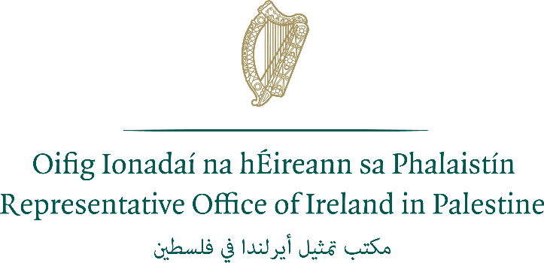  Palestine Scholarship Programme – 2020 Application Form  Closing Date: 30 January 2020  This form is designed to be completed in Microsoft Word before being printed and signed  Your application will be photocopied. Pages should NOT be stapled together. Please do not use spiral or other binding. Use single-sided format for all forms and accompanying documents. | Please  attach two recent  passport-size photographs of  yourself here.  (Attach using glue  not staples or tape.  If your photos are together in a strip,  you do not need to  separate them)
SECTION ONE: PERSONAL INFORMATION
1a. Please write your full name in the order it would appear in an official document. This must match the name recorded in your passport if you have one.

Full Name:

1b. Name that you are known by (i.e. your first name or given name ):
2. Male Female

3. Date of Birth / / (Day / Month / Year)

4. Place of Birth

5. Nationality

6. Please give an email address for an account which is checked regularly. It is vital that you can be contacted by email regarding your application. If writing in an email address it should be clear and legible. If you use more than one email address you are asked to list a second email address below.

Email:

Alternate Email:

SECTION TWO: PROPOSED COURSE(S)
7. In this section, you should list the course title and academic institution for your first and second choice taught Masters courses. You are required to specify a particular course and academic institution in each case, not give a general course type.

You must select courses from the Ireland-Palestine Scholarship Programme Directory of Eligible Postgraduate Courses. Courses should be listed according to first and second preference and are an important consideration in the review of applications.

You should ensure that you hold the specified qualifications and academic grades required for the academic courses you intend applying for. These can be found in the Ireland-Palestine Scholarship Programme Directory of Eligible Postgraduate Courses and on the relevant college website. It is your responsibility to ensure that your academic qualifications are of sufficient standard for your chosen course.

This is a rough guide to how the grading system in Ireland might compare to the grade/GPA system at Palestinian universities.

Verbal Grade | % Grade in Ireland | Equivalent Local Grade | Equivalent Local GPA
First Class Honours (1st) | 70% or above | 90% - 100% | 3.5 - 4.0
Second Class Honours, Grade 1 (2:1) | 60% or above | 78% - 89% | 3.0 - 3.49
Second Class Honours, Grade 2 (2:2) | 50% or above | 70% - 77% | 2.5 - 2.99
Third Class Honours (3rd) | 45% or above | 65% - 69% | 2.0 - 2.49
Pass | 40% or above | 60% - 64% | 2.0
Fail | Less than 40% | 0% - 59% | Less than 2.0

Note: These are suggested equivalents only.

Please choose your courses carefully. You will not normally be permitted to revise your choices after submission, unless a programme does not run. Applicants are therefore advised to thoroughly research their course choices.

Courses must begin no earlier than July 2020.

Note: Masters degrees by research are not eligible for the programme. Part-time courses are not eligible for this programme.

First Course Choice

Name of Educational Institute:

Full title of Course:

Course Code*: (if available - can be found on course website)

Course start date: / (Month/Year) Course Duration:

Second Course Choice

Name of Educational Institute:

Full title of Course:

Course Code*: (if available - can be found on course website)

Course start date: / (Month/Year) Course Duration:

*See course directory for course codes.

SECTION THREE: EDUCATION, QUALIFICATIONS AND SCHOLARSHIPS
8. You must provide an official copy of the academic transcripts and completion certificate for each higher education qualification you have completed (see note in Section Eight regarding certified documents).

Qualification | Educational Institution | Dates  From – To  (Month/Year) | Location | Final Grade Achieved

9. Please give details of any relevant professional qualifications awarded including dates, awarding body and type of award received.

10. Please give details of any educational or vocational training courses attended (other than those mentioned in Q8/9), including dates, training body and certification received, if applicable.

11. Have you previously received a higher education scholarship or award funded by any government or international organisation?

Yes No

If you answered Yes, write the name of the scholarship, the year(s) on scholarship and the name of the qualification or course undertaken.

i.

ii.

12. Have you ever previously applied for an Irish Aid Scholarship?

Yes No

If yes, please list year(s) in which you previously applied and if you were successful:

13. Have you applied, or are you intending to apply, for another scholarship at the same time as this application?

Yes No

If you answered Yes, provide the full name of the sponsor and the scholarship.

Sponsor:

Scholarship:

SECTION FOUR : EMPLOYMENT DETAILS
14. Please provide the following information in relation to your current employment, if applicable:

Employing Organisation:

Address (please include city and country):

Telephone: Fax:

E-mail:

15. What type of organisation do you work for?

Public sector Community/Non-Government Organisation (NGO)
Private sector Faith-based Organisation
International NGO Other (please state):

16. Date you started with this organisation: / / (Day/Month/Year)

Title of current post:

Date you started in this post: / / (Day/Month/Year)

List in chronological order the previous positions held in this organisation and dates (please provide month and year of commencement of position):

17. Briefly describe the work of your current employer, if applicable:

18. Please provide details of your current responsibilities:

19. Please provide information, on your previous employment, if applicable.

Name of Organisation | Address | Dates  From-To  (Month and Year) | Location | Position Held  Tasks and Responsibilities

SECTION FIVE: STATEMENT OF INTENT

Please complete this section paying careful attention to the suggested word count. Please note that the quality of your answers will be a key factor in how your application will be graded by the selection panel.

20. The key achievements in my academic or professional career to date (approximately 400 words)*

21. Why I want to pursue my nominated course(s) (approximately 400 words)*

22. How I will use my new skills and knowledge (approximately 200 words)*

23. How I believe my proposed study will contribute to future development in Palestine
(approximately 200 words)*

*Plagiarism will result in your disqualification from the program.

SECTION SIX : ENGLISH LANGUAGE COMPETENCY
24. Have you completed an IELTS (International English Language Testing System) academic test?*

No Yes

I have attached the original copy of my IELTS result to this application form.

Date of test: / / (Day/Month/Year)

Overall IELTS (academic stream) score:

Listening band: Reading band: Writing band: Speaking band:

* You will be required to demonstrate a minimum overall IELTS score of 6.5 for English language proficiency. No exceptions are made.

Please note that entry to some courses may require an overall IELTS score above 6.5 and/or a minimum score in specific bands. Applicants should always refer to the course information for further details.

For additional information see p iii.

SECTION SEVEN: SUPPLEMENTARY INFORMATION
25a. Do you have a passport? Yes No (Go to Q26)

b. Country issuing passport:

c. Date of expiry : / / * (Day/Month/Year)

* For study in Ireland, your passport should be valid for the duration of your study period.

d. If you hold a passport for another country or a diplomatic passport, please give details:

26. Have you ever been convicted of a criminal offence? Yes No

If the answer is Yes, please provide details of the offence for which you were convicted, including the nature of the offence and the sentence received.

27. Please provide (a) a home mailing address (not a PO Box) where registered post can be delivered and signed for, and (b) a PO Box address if you have one.

a) Home Address (please include city and country):

b) PO Box Address, if applicable (please include city and country). Please indicate if you wish to use this address as your primary mailing address for correspondence purposes by ticking the box:

c) Contact phone numbers: (Please give at least two numbers if possible, e.g. work, mobile, landline)

Your main telephone number:

Other telephone number (1):

Other telephone number (2):

28. Name someone who can be contacted in an emergency.

Name:
Relationship to you (e.g. spouse, father, mother, sibling):
Home Address (please include city and country):

What telephone numbers can be used to contact them? (Please give at least two numbers if possible)

Main telephone number:

Other telephone number:

Does this person speak English? Yes No

Clearly write an email address for an account which they check regularly.

Email:

SECTION EIGHT: DOCUMENTATION CHECKLIST
All relevant documents listed below must be included with your application, in the sequence shown.

Supporting documents must be official or original documents. It is recommended that you obtain a minimum of three official copies of all of your documents as you will need to provide copies for your course applications, as well as retain a copy for yourself. Where original documents are not in English, you must provide certified true copies of official English translations.

You should mark each box below with ‘X’ to indicate that the document is present. If you do not possess a particular document (e.g. birth certificate) you should explain in the notes section below.

You are advised to make electronic scans of all documents submitted with your application.

Essential

An official copy (not a photocopy) of the completion or graduation certificate for each higher education qualification that you have completed (in English).
An official copy (not a photocopy) of the academic transcript for all higher education qualifications and the grading schedule for each qualification (in English).
Letters from your two academic referees with original signatures (Q21). E-signatures are not accepted.
A copy of the identity page of your passport*
A copy of your ID card
An original IELTS, iBT, or ITP score report. Photocopies will not be accepted. Test results must be no more than 24 months old by the commencement of study (Score reports should be dated September 2018 or later).
*If you are shortlisted following the interviews, you will be required to submit a certified copy of the identity page of your passport.

If applicable:

A certified copy of your birth certificate (in English), only applicable where no passport is provided.
A certified copy of official evidence of any name change (in English).

Do not include copies of certificates from short courses or for non-degree level programmes.

NOTES ON DOCUMENTATION:

SECTION NINE: DECLARATION
I am in good health and if accepted for the Ireland-Palestine Scholarship Programme will undertake the necessary medical examinations and provide the required medical certificates.

I give my permission for information and documents submitted as part of my application to be shared with:
- the managing agencies for the Ireland-Palestine Scholarship Programme;
- appropriate staff of my nominated Higher Education Institutions, as required, regarding any course applications and place offers;
- any other individuals, companies and/or organisations as necessary to make arrangements related to my participation in the Scholarship Programme.
When your application form is received, we create a record in your name, which contains much of the personal information you have supplied. This personal record is used solely in processing your candidature. Such information held is subject to the rights and obligations set out in the Data Protection Acts, 1988 and 2003.

I understand the purpose for which IPSP scholarships are awarded and the necessity to abide by the conditions specified.

- I certify that all the information I have given is true, complete and accurate to the best of my knowledge.
- I certify that my answers to questions 20-23 are my own work, and that it is not copied from any other person’s work.

Signature: Date: / / (Day/Month/Year)

