Personal Information

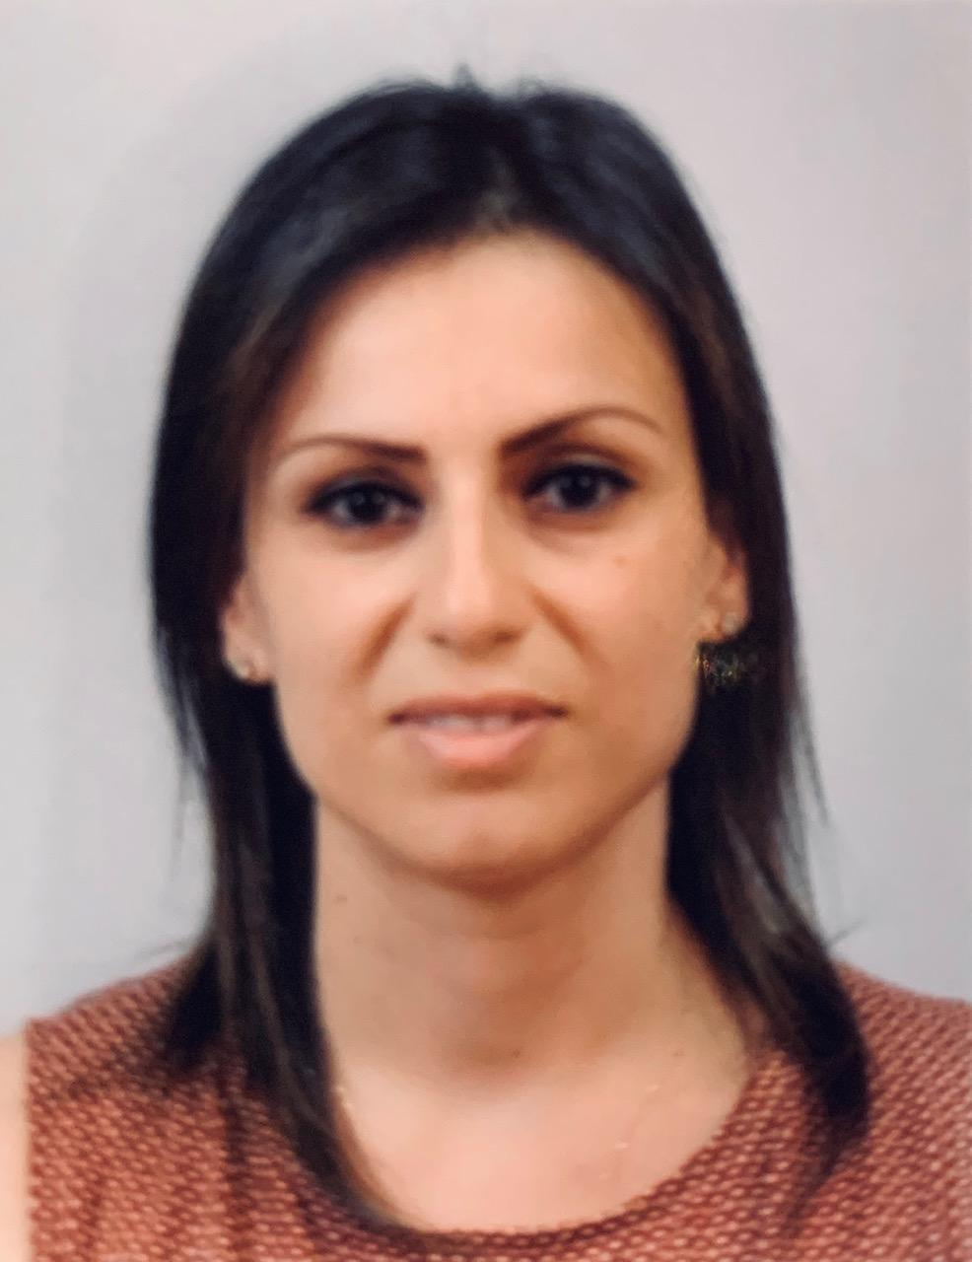
Name: Christine Mousa Alloush/Hadid

Date of Birth: 21 April 1982

Nationality: Palestinian

Martial Status: Married

Residence: Ramallah- West bank- Palestine

Tel.: (Home) 02- 2952888
(Office) 02-2970555
(Mobile) 0599-373744

E-mail: christine.alloush@gmail.com
Christine.Hadid@aaup.edu

Mailing address:
P.O Box 2085
Ramallah / West bank
Palestine

Education

- Tawjihi (General ministry high school examination), Latin Patriarchate High School, Birzeit, 2000, scientific stream, Degree: 92.8.
- B.Sc Architectural Engineering-2000-2005, Birzeit University, Palestine. With Emphasis on Urban Planning. Graduation Project “Rehabilitation and revitalization of the old town of Birzeit”
- Msc. Urban Planning and Landscape Architecture, Birzeit University, 2015. with Masters’ thesis co-supervised with the Department of Critical Heritage Studies at the University of Gothenburg, Sweden. “Understanding the Rural Landscape of Palestine by Exploring Locals’ Conceptions: The Case of Dair Ghassaneh Village.

Work Experience

- 2005 - 2010, Architect at InEx for Engineering, designer and supervisor for different kinds of projects with various scales.
- 2010-2011 freelance architect.
- 2011-2015, Teaching Assistant, Department of Architecture at Birzeit University. Assigned courses were concerning urban planning, advanced building design, building construction and landscaping as well as architectural presentation and history of architecture.
- 2015- present, Part time Architect & Graphic designer at IPrint
- 2018- present, Part time Architect at Designit Architectural Studio
- 2019- present, Full time Instructor at the Arab American University of Palestine, BA Program of Interior Architecture.

During the years of study:
- Worked on several design projects including multifunctional buildings, housing projects, Kindergartens, galleries, and landscaping projects. Also worked on several planning projects such as new master plan for some Palestinian villages like Qarawat Bani Zaid and two other urban design projects for Bani zeid (Dair Gassaneh and Beit Reema).
- Worked as a trainer at Al-Dyar consultants, as an architect and urban planner during july-september 2004.
- Worked for 9 months with Riwaq on the rehabilitation of the historic center of the village of Dair Gassaneh; including surveys, maps updating and detailed areas’ design.
- During the postgraduate study, worked mainly on Urban planning and Urban design projects focusing on planning for better quality of life in Palestine; in rural areas and urban centers.

Examples of Design and Construction Projects during working at InEx:

- 2005- Greek Catholic Housing Project - Al Tireh- Ramllah.
- 2005- Villa Mr.Samir Zreiq - Al Tireh- Ramllah.
- 2005- Elite Building (Office Building) - Al masyoon- Ramallah.
- 2005- Villa Dr.Omar Jarallah - Al Tireh- Ramllah.
- 2006- Greek Catholic School Renovation (kindergarten, playground, new toilets units, new floor for the school)–Ramallah.
- 2007- Safad office building - Al masyoon- Ramallah.
- 2008- Yacoob Jasser’s Building (a new 4 floors building over an old one) - Al Qdaireh - Ramallah.
- 2009- Al-Baba Residential Building.

Interior design and Finishing Projects during working at InEx:

- 2006-Expotech exhibitions, Safad Booth.
- 2007-Expotech exhibitions, Safad Booth- First Prize winner for the Design.
- 2008-The Motor Show, Peugeot cars’ Booth.
- 2008-Peugeot’s ShowRoom.
- 2009- Istifan’s family apartment in al Tireh-Ramallah.
- 2009-fully designed the location for the Satellite Channel (Falasteen el Ghad). Interior functions, Studios, wood works, exterior façade cladding and entrances.
- 2010- Must-Have fashion store showroom in Al Bardooni building-Ramallah.

In addition to many other freelance projects including: construction, finishing & renovations.

Urban Planning and Urban Design Projects

- 2004 new master Plan for the Village of Qaraqat Bani Zaid
- 2004 improving the master Plan for Beit Reema and Dair Ghassaneh
- 2005 worked with a team for designing the Palestinian governmental compounds (Almokata’a).
- 2006 Designing the Plan for revitalizing the Old Town of Birzeit with Al rozana association, preparing for the first heritage week.
- 2011 Designing a development Plan for Ein Qinya.
- 2012 designing a new plan for improving solid waste management in the city of Ramallah.
- 2013 urban design and landscape analysis creating improvement plan for Al Tireh neighborhood in Ramallah. (Infrastructure, open spaces, services).
- 2018 conservation plan for the village of Qalendia in Ramallah as part of the project of conservation and rehabilitation of the historic centers of the north-east villages of Jerusalem with Riwaq.
- 2018 Conservation and rehabilitation plan and design of Al hoqqieh Hosh and its adjacent compound in Qalendia village under a design project with Riwaq.

Graphic Design Expertise
- extensive experience in all aspects of Graphic Design, printing and publishing.
  - worked on design and installation of many art exhibitions in Ramallah
  - designed many books, booklets, brochures, cards, logos, campaigns etc….

Training Courses & International Participations:

- 2012, joined the intensive course "City as Collective Memory in Constant Progress". Department of architecture at Birzeit University in collaboration with the division of Urban and Regional Studies, Royal Institute of Technology (KTH) in Stockholm, Sweden.
- 2013, joined the intensive workshop "Heritage Everyday Life And Planning" organized by the Urban Heritage Cluster at the Department of Conservation, University of Gothenburg (UG), Sweden, in cooperation with the Architectural Department and the Master Program in Urban Planning at University of Birzeit
- 2014, participated in the permanent European conference for the study of the rural landscape (PECSRL 2014) in Sweden. Presented own Paper “Understanding the rural landscape of Palestine: exploring local conceptions in the village of Dair Ghassaneh”.
- 2016, certified training in conservation, “Site Management Planning and Management of Conservation Projects for Professionals”. 3 months course arranged by the welfare association in cooperation with ICCROM. Was an intensive training with experts in conservation, the main outcome of the course was creating a conservation plan for a case in the village of Qalandia, on which all skills acquired through the course have been applied and experimented.
- 2018, AESOP Annual Congress, July 2018 in Gothenburg, Sweden: making space for hope, presenting the paper: “Neoliberal Powers and Spatial Transformations Under Colonialism: Rapid Urbanization and Heritage Challenges in The City of Ramallah”
- 2018, 3 months Training Workshop at Riwaq center for architectural conservation, training on conservation techniques, materials, design, site works and project management. (the project of Jabba’, Kofr Aqab, Al Jeeb, and Qalendia).

Engineering Expertise:

A highly adaptable professional engineer with:

- Expertise in Exterior, interior and Landscape design.
- Expertise in architectural conservation and Heritage studies.
- Expertise in all aspects of design from conceptual and detail design through to construction and site management.
- Expertise in site survey methods and reporting.
- Expertise in Graphic design.
- Supervisory and team leadership competence.
- Technical problem-solving talents.

Interests:

With a good experience in heritage studies; interested in heritage research focusing on understanding the challenges that the built heritage is facing and finding sustainable solutions for its safeguarding and continuity.
Written papers yet to be published:

- “Understanding the rural landscape of Palestine: exploring local conceptions in the village of Dair Ghassaneh”.
- “Neoliberal Powers and Spatial Transformations Under Colonialism: Rapid Urbanization and Heritage Challenges in The City of Ramallah”
- The Heritage Values in Palestine: a study of memory & attachment.

Other Information:

Board member in Al-Rozana association for rural development since establishment in 2006:
The aim was the revitalization of the old town of Birzeit, encouraging rural development, and help developing the economic base of Birzeit and neighboring villages. the association also arranges regular activities encouraging echo tourism, landscape conservation and supporting local Palestinian products.

Computer skills:

- Excellent in using Mircrosoft office (excel, word, powerpoint).
- Excellent in Autocad 2D & 3D
- Excellent in graphic design soft wares; Illustrator and InDesign
- Good in Adobe Photoshop
- Good in sketch up
- Good in 3D max.
- Good in using Geographic information systems (GIS).

Languages

- Arabic: mother language
- English: fluent (reading, writing, speaking)

References

Samar. W. Alnazer, Assistant Professor, Dr. Arch. Department of Architectural Engineering, Master program in Urban planning and Landscape Architecture, Birzeit University; P.O. Box 14 – Birzeit Palestine. Office: 00972-2-298 2119; mobile: 00972-59-9736655. MAs thesis supervisor.
snazer@birzeit.edu

Manal Al-Bishawi , Assistant Professor, Dr. Arch. Department of Architectural Engineering , Director of Master program in Urban planning and Landscape Architecture, Birzeit University; P.O. Box 14 – Birzeit Palestine. Office: 00972-2-298 2188; mobile: 00972-59-9870439 Fax: 00972 2 298 2984. My instructor and Thesis Reader.
mbishawi@birzeit.edu

Feras Hammami, Postdoctoral Research Fellow, Critical Heritage Studies, Department of Conservation, University of Gothenburg, Box 130; SE 405 30 Gothenburg, Sweden, Office 0046 31 786 5700; mobile 0046 73 968 6027. MAs thesis supervisor.
feras.hammami@gu.se; www.conservation.gu.se

Lubna Shaheen, Assistant Professor, Dr. Arch. Department of Architectural Engineering, Master program in Urban planning and Landscape Architecture, Birzeit University; P.O. Box 14 – Birzeit Palestine. Office: 00972-2-298 2119; mobile: 00972-59-9963950. Instructor, worked together at Birzeit University.
lshaheen@birzeit.edu

