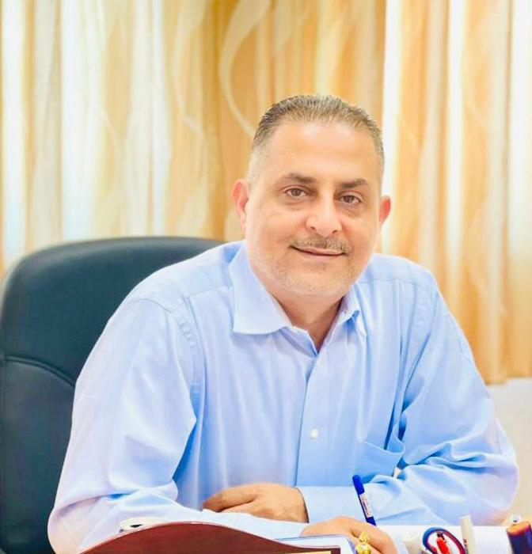 |  | Dr. Mohammed JALLAD, Ph.D. FNP-BC.ER-CNP.
Profile  Board licensed Family- ER Nurse Practitioner with 20 years of experience in direct patient care. Strong background in Emergency medicine, Neurology and Neurosurgery. Self -motivated and professional with a commitment to provide quality care. Strong organizational and leadership skills. Well-qualified in teaching, staff training and development  Contact  059-301-4546  EMAIL:  Moejallad3@gmail.com  Mohammed.jallad@aaup.edu |  | WORK EXPERIENCE  Associate professor. Arab American University. 08/2019 – Present  Jenin, Palestine.  Accepted an offer from the Arab American University to start the master’s degree program in Emergency Nursing (the first in the area) and join the committee responsible for managing the other graduate Nursing programs at the AAUP.  The Committee provides recommendations to the academic board on learning and teaching policy, strategies, initiatives, and innovation that promotes the interests of the University including meeting legislative and professional requirements, the maintenance of academic standards and fostering high-quality learning.  Neurosurgery/Hospitalist NP. 07/2018 -06/2019  THE MERCY HEALTH- ST VINCENT MEDICAL CENTER. Toledo, Ohio.  Worked in collaboration/ supervision of team of neurosurgeons to diagnose, treat and manage care of neurosurgical patients with neurological emergencies.  Medical Scribe Program Director. 06/2017 - 12/2018  MEDICAL SERVICE STAFFING. Toledo, Ohio  Developed and instituted a comprehensive medical scribe training program to include ICD-10 billing & coding practices.  Adult/Pediatric Neuro-NP 10/2015 - 03/2018  THE TOLEDO CLINIC PEDIATRIC AND ADULT NEUROLOGY － Toledo, OH  Worked, in collaboration and under supervision, with team of neurologists to diagnose, treat and manage neurological disorders including seizures, strokes, head injuries, and intramuscular disorders including MS, genetic disorders, ADHD, learning disabilities, and sleep  disorders. Specialized in migraine's preventive and abortive treatment including administering nerve blocks and BOTOX injections. Gained experience in managing vagal nerve simulator devices of patients with intractable seizures and epilepsy.  Certified Emergency Nurse Practitioner 08/2007 - 09/2015  EMERGENCY PHYSICIANS OF NORTHWEST OHIO, EPNO. Toledo, OH  -Proficient skills in assessment, diagnosis, management, treatment, and evaluation of Emergency Department patients with life threatening and non-life-threatening conditions, in collaboration with the Attending Physician at The Toledo Hospital ER (Level I Trauma), Flower Hospital ER , and Lima Memorial ER.  -Was Responsible for training new NPs, PAs, and First Year ER residents  -Excellent experience in Urgent Care seeing an average of 60-80 patients per day.  -Very skillful in most ER procedures including laceration repair, nerve blocks, fracture closed reductions and splinting, slit lamp eye exam, eye foreign body removal, nasal packing, incision and drainage, lumbar punctures, central lines insertion, X-ray, and EKG  interpretations.  Rapid Response Team Specialist 01/2006 - 07/2007  PROMEDICA- TOLEDO HOSPITAL. Toledo, OH  Acted as a consultant to provide early assessment and rapid intervention to promote better patient outcome and reduce cardiac/respiratory arrests throughout the hospital.  Emergency Room RN / Charge Nurse 08/2002 - 01/2006  THE TOLEDO HOSPITAL. Toledo, OH  With four years of nursing experience, specializing in treating severe, critical, and traumatic injuries under extreme circumstances in Ramallah, Palestine. I was able to further develop these skills as an ER Nurse/Charge Nurse at an 83,000-visit level I Trauma Center.  Provided prompt care to diverse patient population in high stress situations of 70 bed emergency department.  TEACHING EXPERIENCE  - Associate professor. Arab American University. 08/2019 – Present  Jenin, Palestine.  -Part time Clinical Associate, Medical University of Toledo, Toledo, Ohio. August 2005- June 2011  I have taught NURS 4270 Applied Health Assessment Across the Lifespan. I have also taught the HESI exit exam.  -Part time Clinical Associate, Owens Community College, Perrysburg, Ohio. May 2002- August 2005  I have taught NUR 201 - Adult Health Concepts and NUR 202 - Complex Health Concepts  -NCLEX – Part time- Examination Instructor -KAPLAN, Toledo, OH. November 2005 – July 2007  CERTIFICATES AND MEMBERSHIPS  -Board Certified Nurse Practitioner in Ohio/ Michigan  -American Nurse Credentialing Center  -BLS, ACLS, PALS, TNCC  -A member of the American Academy of Nurse Practitioners  -A member of the Ohio Association of Advanced Practice Nurses  -A member of the American Academy of Neurology  -A member of the American Headache and Migraine Association  -A member of American Epilepsy Society  -A member of the American Heart and Stroke and Association  -A member of the Emergency Nurses' Association  References  -Dr. Imad Abu Khader, Dean of Nursing faculty at AAUP, 059-866-6197  -Dr. Brian Kaminski, Toledo ER-Medical Director, 419-346-9450  -Dr. Mamon Maiteh, The Toledo Clinic Neurologist, 248-797-3008

